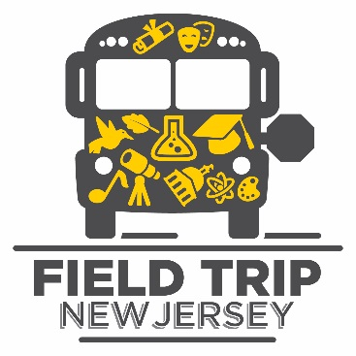
PRINCIPAL VERIFICATION FORM

I approve of the purpose and intention of this field trip for students at our school. I understand that our school may receive up to $700 for transportation costs only for field trips from the Pi Chubb II Field Trip Newark Fund of the Field Trip New Jersey program. The cost of transportation for this field trip will be reimbursed only if our school has completed the proper Bus Transportation Form with the district.

School Name: _____________________________________________
Principal Signature: _________________________________________
Date: ____________________________________________

