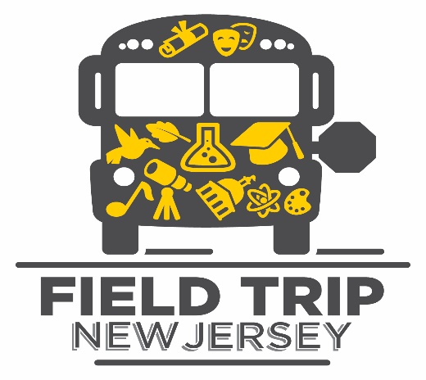

Happy New Year!

Field Trip New Jersey is pleased to announce that it will have two yearly grant application cycles. Below are the dates for which the application will be open to applicants to complete online at fieldtripnj.org.

Winter Cycle 2018
Dates to apply | January 1,2018 – February 16, 2018
Award Announcements | March 16, 2018

Fall Cycle 2018
Dates to apply | September 3, 2018 – October 15, 2018
Award Announcements | November 15, 2018

The FTNJ team asks that schools submit bus transportation invoices no later than July 2, 2018 to receive reimbursement for field trip grants awarded between the months of September 2017 and June 2018.

The Field Trip New Jersey team feels privileged to be able to provide field trip transportation funding that helps enrich the lives of New Jersey youth. The program has been successful in large part because of the dedicated educators who have been willing to take the time to apply for the funding to give their students a new learning experience outside of the classroom.

We are also grateful to the other funders who support the FTNJ Fund, notably the Pi Chubb Field Trip Newark Fund, the Henry & Marilyn Taub Foundation, the Burke Family Foundation, the NJ Historical Commission, and PSEG Foundation. We look forward to continuing to offer this wonderful opportunity with their support and that of others.

If you have questions, please do not hesitate to reach out to info@fieldtripnj.org.

