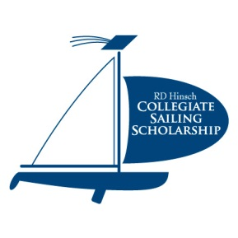

R. D. HINSCH COLLEGIATE SAILING SCHOLARSHIP - 2019 Application

Ralph Hinsch was an active member of the Nyack Boat Club for many years. The purpose of the R. D. Hinsch Collegiate Sailing Scholarship is to perpetuate the memory of Mr. Hinsch and his appreciation for collegiate sailing and the benefits experienced both in skill building and in social activity settings. The fund was established in 2004 to foster future collegiate sailing. The Fund is administered by the Community Foundation of New Jersey.

The R. D. Hinsch Collegiate Sailing Scholarship Fund will provide one scholarship up to $12,000 to a graduating high school senior or a student currently enrolled in undergraduate studies at a college/university within the United States who demonstrates an active and continued interest in sailing. The award is payable in consecutive annual installments of $3,000 if continued eligibility requirements are met. The total amount of the scholarship will be based on the number of years the student has left to complete a four-year bachelor’s degree. In other words a scholarship recipient that is entering their junior year would be eligible for a maximum of a $6,000 scholarship payable over two years.

Scholarships are awarded at the discretion of the Foundation’s Board of Trustees based on the R.D. Hinsch Collegiate Sailing Scholarship Selection Committee recommendations. Scholarship award will be applied for tuition expense only.

Criteria:

The following criteria will be used when evaluating each application:
- Student must be accepted and/or enrolled on a full-time basis in an accredited college or university within the United States and pursuing an undergraduate degree.
- Student will show an interest in pursuing sailing. Although it is encouraged, there is no requirement that the student race in the collegiate setting to receive or sustain the scholarship.
- Student must remain in good academic standing to be considered for scholarship installments
- Resume and essay to be submitted along with application (attached).

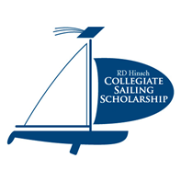
R. D. HINSCH COLLEGIATE SAILING SCHOLARSHIP
APPLICATION – FALL 2019 (Filing Deadline: Must be postmarked by May 31, 2019)

Student Information

Student’s Name:
Home Address:
City, State ZIP
Home Phone:
Mobile Phone:
Email Address:
How did you hear of the scholarships?

School Information
Name of University/College
Expected Graduation Date
Address at College (if known)

University/College Bursar’s Office Contact Information:
Name:
Address:
City, State ZIP
Telephone:
Student ID #

Please attach your resume and a short essay describing your sailing interests and experiences; for example, racing, cruising, day-sailing, teaching, and tell us what sailing means to you.

Applicant Signature: Date
Parent/Guardian Signature: Date

Please mail application, resume and essay to: Community Foundation of NJ
Scholarship Office
Post Office Box 338
Morristown, NJ 07963-0338
973.267.5533 x 227 or fkrueger@cfnj.org

