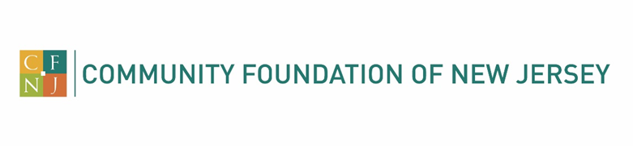
Frank Mongelli Jr. Scholarship - 2024 Application
Deadline: May 1, 2024

Frank Mongelli, Jr. passed away at 22 years old on March 9, 2008 as the result of a drug overdose. The epidemic of alcohol/drug abuse continues to affect the entire country. In loving memory of their son, Donna Esposito and her late husband, Michael, established the Frank Mongelli Jr. Scholarship with the hope that through education, prevention and treatment, others might be spared from enduring the loss of a loved one so precious and irreplaceable.

The scholarship assists students who are enrolled or accepted at an accredited college or university in New Jersey in a graduate program and plan to pursue a career in Substance Abuse/Addiction Counseling.

Scholarship Award: $2,500 (lump sum). The scholarship is intended to be used for tuition and mandatory educational fees. The scholarship award is made payable to the college or university for further credit to the student’s account.

Requirements:
The applicant must:
- Be enrolled or accepted at an accredited college or university in New Jersey pursuing a master’s degree in Substance Abuse/Addiction Counseling.
- Be in good academic standing.
- Complete a written statement, 500 words or less, describing their vision of substance abuse/addiction counseling and the contribution they expect to make to the profession.
- Submit a letter of recommendation that speaks to the applicant’s promise as a contributor to the substance abuse/addiction counseling profession.
- Official transcript
- Resume detailing extra-curricular activities, interests, leadership positions, community/volunteer involvement, and work experience (paid or unpaid).
  - Please include number of hours in which your activities were performed.
- Return the application form and supporting materials no later than May 1, 2024.

Name:
Address:
City, State, ZIP:
Phone: Email:

Date of Birth: (mm/dd/yyyy)
College/University Current Attending/Planning to Attend:
Degree Pursuing:
Career Plans:
Anticipated Date of Graduation: (mm/yy)

Required Signature: I declare that I have met the eligibility requirements for the scholarship program(s) indicated in the instructions of this application form. I further declare that all statements made on this application form or in conjunction with this application form are my own and are accurate and true.

Scholarship donors very much appreciate knowing the students who directly benefit from their scholarship funds. This communication helps donors understand the positive impact of their generosity. By allowing the Community Foundation of New Jersey to release your name, contact, and academic information, you are helping us connect donors with future scholars. This simple act helps ensure that more students will continue to benefit from these generous gifts.

By submitting this application, you grant CFNJ permission to verify the information you provided and share your application with members of its Scholarship Review Committee. I further authorize the release of my name, contact, and academic information to scholarship donor(s) and others in conjunction with any CFNJ Scholarship(s) I may receive. I consent that this release will remain in effect until revoked by me in writing.

If selected to receive an award, the recipient will be asked to submit a short biography, photo (optional) and thank you note which we will forward to your scholarship donor.

Applicant’s Signature: Date:
Print Name:

Please return the application and supporting documentation in one envelope to:
Community Foundation of New Jersey
Post Office Box 338
Morristown, NJ 07963-0338
Or scan it to: fkrueger@cfnj.org
Contact: Faith Krueger – 973.267.5105

